Industrial Mini PC
QY-B5300-1
Small Size Series

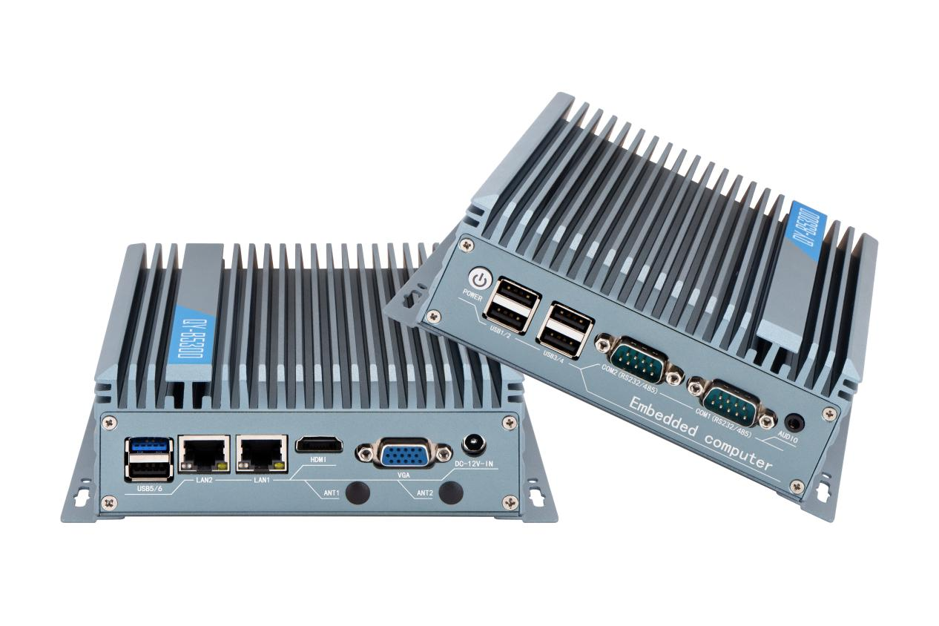
Products Features:
- Industrial-Grade Embedded Fanless Mini PC
- Intel Celeron / Atom and Core 4/5/6/7/8/10/12/13th-i3 / i5 / i7 CPU
- 2*LAN, 6*USB, 2*COM, 1*HDMI, 1*VGA
- 1*Mini PCIE Expansion Slot, Support 4G and WIFI Module
- Support Optional Fan Design Chassis
- DC 12V Power Input
- -20℃~60℃ Temperature Can Keep 24/7 Work Stably

QY-B5300-1
1.Mother Board Specification:
Model | QY-B5300-1
CPU | N2840 / J1900  i3-5th  i5-4th / 5th  i7-4th / 5th
Memory | 1*DDR III RAM Slot, Up to 8GB
Storage | 1*MSATA SSD Slot  1*SATA SSD Slot
Display^{[1]} | 1*HDMI: Resolution up to 3280*2000@60Hz  1*VGA: Resolution up to 1920*1200@60Hz
Expansion | 1*Mini PCIE Slot, Support 4G and WIFI module
Ethernet | 2*Realtek 8111E LAN Chip (10 / 100 / 1000 Mbps, RJ-45 Type)
USB | 1*USB 3.0 (Type-A)  5*USB 2.0 (Type-A)
COM | 2*RS-232 (DB9 Type)
Audio | 1*Line-Out
Notes:
[1]: The maximum resolution and frame rate of the display interface output depends on the CPU.

2.Device Specification:
QY-B5300-1
Power Input | DC 12V
Power Input | Support Auto-Start
Power Input | 1*2.5mm Circle Type DC Plug
Working Temperature | -20℃~60℃, Support 24/7 Working
Structure | Fully Enclosed Aluminum Alloy Material
Heat Dissipation | Fanless Design, Conduction Heat Dissipation
Heat Dissipation | Fan design Chassis (optional)
Installation | Desktop / Embedded / Wall Mount
Size | 159.6mm*127mm*53mm
System | Windows and Linux

QY-B5300-1
3.Ordering Information:
Model | CPU | LAN | USB | COM | Display | RAM | SSD | Expansion | Power
QY-B5300-1 | N2840 / J1900  4th / 5th | 2 | 6 | 2*RS-232 | 1*HDMI  1*VGA | 1*DDR 3  Up to 8GB | 1*MSATA  1*SATA | 1*Mini PCIE | DC 12V
QY-B5300-2 | J6412 | 2 | 4 | 2*RS-232/485 | 2*HDMI  1*DP | 1*DDR 4  Up to 16GB | 1*MSATA  1*SATA | 2*Mini PCIE | DC 12V
QY-B5300-2 | N95 / N100 |  |  |  |  |  | 1*M.2 NVME  1*SATA | 2*M.2 | DC 12V
QY-B5300-3 | 6th / 7th | 2 | 8 | 2*RS-232 | 1*HDMI  1*VGA | 1*DDR 4  UP to 16GB | 1*M.2 NVME  1*SATA | 1*Mini PCIE | DC 12V
QY-B5300-3 | 8th / 10th |  |  |  |  | 2*DDR 4  UP to 32GB | 1*M.2 NVME  1*SATA | 1*Mini PCIE | DC 12V
QY-B5300-3 | 12th / 13th |  |  |  |  | 1*DDR 5  Up to 32GB | 1*M.2 NVME  1*SATA | 1*Mini PCIE | DC 12V
QY-B5300-4E | J6412 | 4 | 6 | 2*RS-232 | 1*HDMI  1*DP | 1*DDR 4  Up to 16GB | 1*M.2 NVME  1*SATA | 1*Mini PCIE  1*M.2 | DC 12V
QY-B5300-4E | N100 |  |  |  |  |  | 1*MSATA  1*SATA | 1*M.2 | DC 12V
QY-B5300-6C | J6412 | 2 | 4 | 2*RS-232/485  4*RS-232 | 2*HDMI  1*DP | 1*DDR 4  Up to 16GB | 1*MSATA  1*SATA | 2*Mini PCIE | DC 9-36V
QY-B5300-6C | N95 / N100 |  |  |  |  |  | 1*M.2 NVME  1*SATA | 2*M.2 | DC 9-36V

4.CPU Information:
CPU | Specification
N2840 | 2 core, 2 total threads, 2.16 GHz to 2.58 GHz, 1 MB cache | Max to 8GB for 1*RAM 3 slot
J1900 | 4 core, 4 total threads, 2.00 GHz to 2.42 GHz, 2 MB cache | Max to 8GB for 1*RAM 3 slot
i5-4300U | 2 core, 4 total threads, 1.90 GHz to 2.90 GHz, 3 MB cache | Max to 8GB for 1*RAM 3 slot
i7-4600U | 2 core, 4 total threads, 2.10 GHz to 3.30 GHz, 4 MB cache | Max to 8GB for 1*RAM 3 slot
i3-5005U | 2 core, 4 total threads, 2.000 GHz, 3 MB cache | Max to 8GB for 1*RAM 3 slot
i5-5300U | 2 core, 4 total threads, 2.30 GHz to 2.90 GHz, 3 MB cache | Max to 8GB for 1*RAM 3 slot
i7-5600U | 4 core, 8 total threads, 2.60 GHz to 3.20 GHz, 4 MB cache | Max to 8GB for 1*RAM 3 slot
QY-B5300-1

5.System Information:

CPU | System
N2840 / J1900 | Windows 7 / 10 and Linux
4th / 5th | Windows 7 / 10 and Linux

6.Fittings Information:

RAM | DDR 3 | 4GB / 8GB
Storage | MSATA | 64GB / 128GB / 256GB / 512GB / 1TB
Storage | SATA | 120GB / 128GB / 240GB / 256GB / 480GB / 512GB / 960GB / 1TB / 2TB / 4TB
GSM Module | 4G | 4G+GPS
WIFI Module | 7260AC / AX210
QY-B5300-1
7.Package List:
Adapter | 1*12V 5A Adapter
Power Cable | 1*Power Cable
8.Fan Design Chassis:
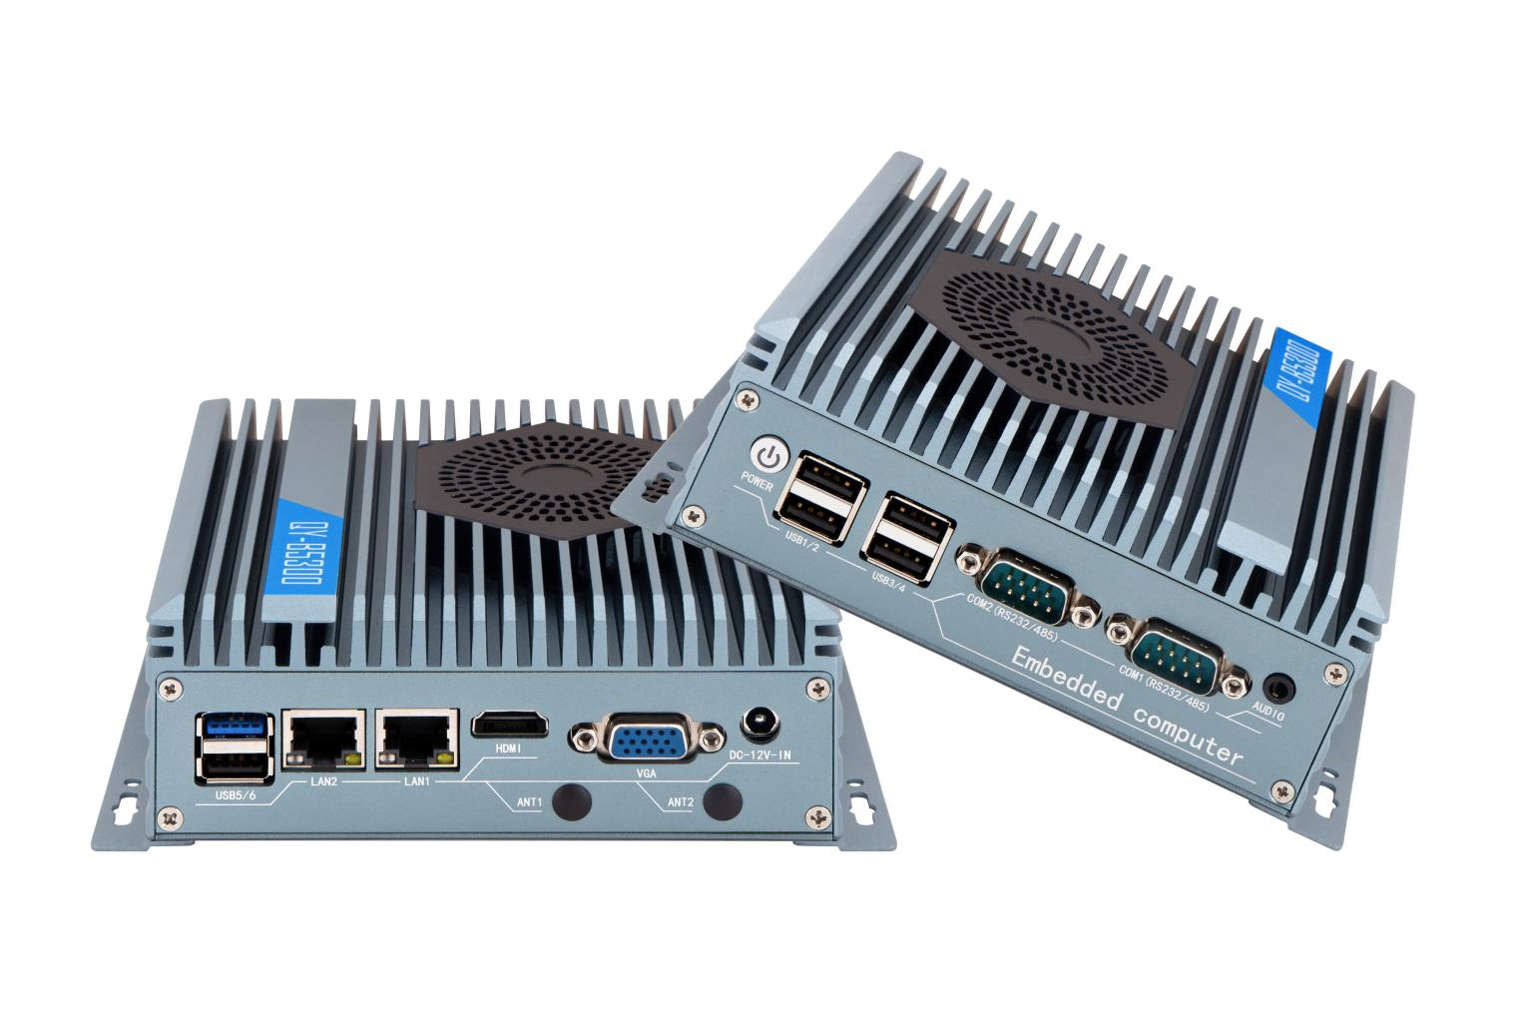
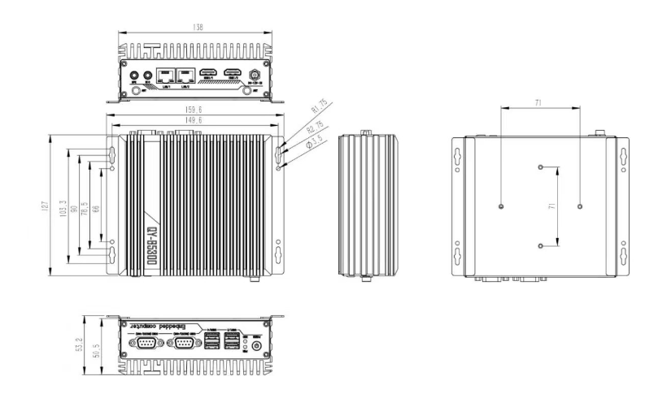
9.Dimensions:
QY-B5300

